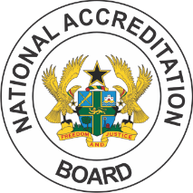
NATIONAL ACCREDITATION BOARD

CREDENTIAL EVALUATION

CONSENT FORM

FULL NAME
FIRST NAME | MIDDLE NAME | SURNAME

PREVIOUS NAME (IF APPLICABLE)
FIRST NAME | MIDDLE NAME | SURNAME

DATE OF BIRTH
ADDRESS

(dd/mm/yyyy)

DETAILS OF QUALIFICATION(S)
INSTITUTION NAME | COUNTRY | DATES ATTENDED  From:_______________To:______________  From:_______________To:______________  From:_______________To:______________  (mm/yyyy) (mm/yyyy)
QUALIFICATION(S) | YEAR OF AWARD | STUDENT #

In connection with an application for evaluation of my credential, which includes verification of its authenticity, I authorise the release of information on my enrolment, academic records and awards to National Accreditation Board, Ghana.

Name:……………………………………………………………………………………………………………………………………………

Sign……………………………………………………………………. Date: ………………………………………………………………

The National Accreditation Board is the agency established by the Government of the Republic of Ghana to among other functions, evaluate certificates awarded by recognised institutions in Ghana and elsewhere.

